SELF EVALUTION

**Strengths:**

My strengths are I am a fast learner, Fast learner and motivated person.

**Weakness:**

My weakness is easy get a trust any person I think it’s me weakness.

**Areas for Growth:**

I have gained my knowledge in technical skills like I have know in Hardware, Linux, Windows server and Linux server, Cyber security and cloud computing.

**LINKDIN PROFILE:**

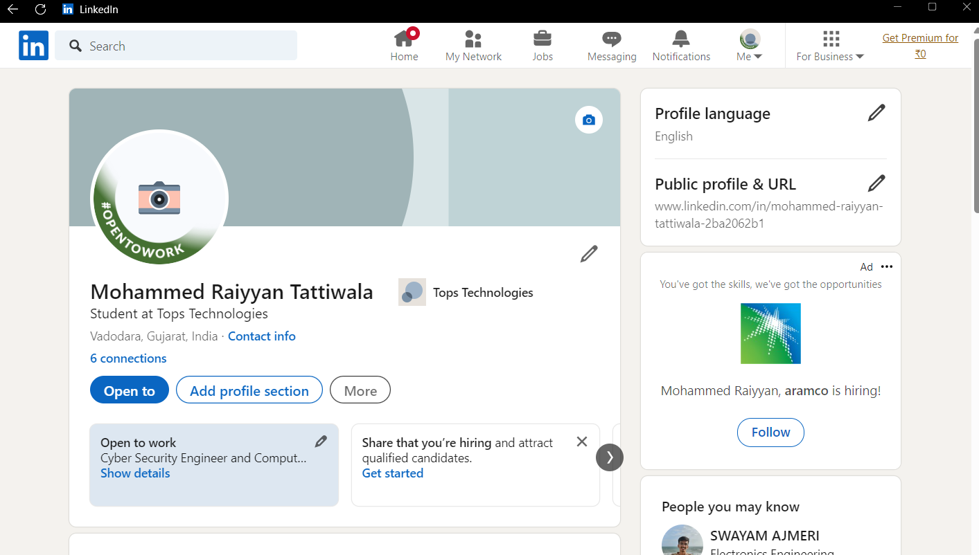

**Summary:**

I (M. Raiyyan), am looking for an opportunity to kick-start my professional career in the field of Cyber Security.

If you provided opportunity to prove my worth skillfully that will contribute to the manifold development of both, the organization that I am working with and me as well. Hence, I hereby look forward for your kind consideration and co-operation. Your positive response is most awaited**.**

EDUCTAION

JUNE 2019- MARCH 2022

THE MAHARAJA SAYJIRAU GAYAKWAD UNIVERSITY OF VADOARA

BACHELOR OF COMMERCE

6.68 CG PA

APRIL 2008 – APRIL 2019

ZENITH HIGH SCHOOL VADODARA

GOOD BREEDING

• COMPUTER HARDAWARE

• NETWORKING

• CCNA

• LINUX

• LINUX SERVER

APTITUDE

• LEADERSHIP

• FRIENDLY AND OUTGOING

• PROBLEM SOLVING

• QUICK LEARNER